CERTAINTY FACTORS

A certainty factor (CF) is a numerical value that expresses a degree of subjective belief that a particular item is true. The item may be a fact or a rule. When probabilities are used attention must be paid to the underlying assumptions and probability distributions in order to show validity. Bayes’ rule can be used to combine probability measures.

Suppose that a certainty is defined to be a real number between -1.0 and +1.0, where 1.0 represents complete certainty that an item is true and -1.0 represents complete certainty that an item is false. Here a CF of 0.0 indicates that no information is available about either the truth or the falsity of an item. Hence positive values indicate a degree of belief or evidence that an item is true, and negative values indicate the opposite belief. Moreover it is common to select a positive number that represents a minimum threshold of belief in the truth of an item. For example, 0.2 is a commonly chosen threshold value
Certainty Factors and Facts and Rules
CFs with facts
padre(John, Mary) with CF .90
CFs with rules
(if (sneezes X) then (has_cold X) ) with CF 0.7
– where the CF measures our belief in the conclusion given the premise is observed.
CFs are calculated using two other measures:
1. MB(H, E) – Measure of Belief: value between 0 and 1 representing the degree to which belief in the hypothesis H is supported by observing evidence E.
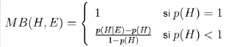
It is intended to capture the degree to which the evidence increases probability: p(H|E)-p(H) in proportion to the maximum possible increase in probability: 1-p(H)
2. MD(H, E) – Measure of Disbelief: value between 0 and 1 representing the degree to which disbelief in the hypothesis H is supported by observing evidence E.
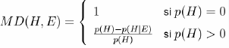

CF is calculated in terms of the difference between MB and MD:
Combining Certainty Factors
• Multiple sources of evidence produce CFs for the same fact.
• For instance, two rules may provide evidence for the same conclusion:
– if P1 Then C CF=0.8
– if P2 Then C CF=0.7
• We need to know how to combine the CFs in such cases
• If two rules both support a hypothesis, then that should increase our belief in the hypothesis.

To combine certainty factors, use an incremental approach as with Bayes
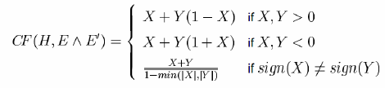
Rules with uncertain evidence
When a rule has a single premise, the certainty of the conclusion is the PRODUCT of the certainty of the premise multiplied by the certainty of the rule:
CF(C) = CF(P) * CF(R1)
Rules with uncertain evidence: negative evidence
A rule is only applicable if you believe the premise to be true
CF(C) = CF(P) * CF(RULE) if CF(P)>0
= 0 otherwise
Rules with uncertain evidence: more than one premise
If a rule has more than one premise:
IF P1&P2&P3 THEN C
• We find the CF of the set of premises – WHICH is just the MIN
CFPs = MIN(CF(P1), CF(P2), CF(P3))
CF(C) = CFPs * CF(RULE) if CFPs>0
= 0 otherwise

BAYESIAN THEORY
It is the basis of uncertain reasoning where the results are unpredictable.
Bayes Rule

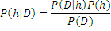
P(h)- prior probability of hypothesis h
P(D)prior probability of data D, evident
P(h|D)-posterior probability
P(D|h)- likelihood of D given h
Axioms of probability
- All probabilities are between 0 and 1 ie0≤P(A) ≤1
- P(True)=1 and P(false)=0
- P(A∨B)=P(A)+P(B)-P(A∧B)

BAYESIAN NETWORK
- A Bayesian network is a probabilistic graphical model that represents a set of variables and their probabilistic independencies. Otherwise known as Bayes net, Bayesian belief Network or simply Belief Networks. A Bayesian network specifies a joint distribution in a structured form. It represent dependencies and independence via a directed graph. Networks of concepts linked with conditional probabilities.

- Bayesian network consists of
  - Nodes = random variables
  - Edges = direct dependence
- Directed edges => direct dependence
- Absence of an edge => conditional independence
- Requires that graph is acyclic (no directed cycles)
- 2 components to a Bayesian network
  - The graph structure (conditional independence assumptions)
  - The numerical probabilities (for each variable given its parents)

For eg, evidence says that lab produces 98% accurate results. It means that a person X has 98% malaria or 2% of not having malaria. This factor is called uncertainty factor. This is the reason that we go for Bayesian theory. Bayesian theory is also known as probability learning.

The probabilities are numeric values between 0 and 1 that represent uncertainties.
i) Simple Bayesian network
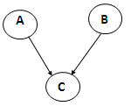
p(A,B,C) = p(C|A,B)p(A)p(B)
ii) 3-way Bayesian network (Marginal Independence)

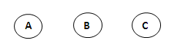
p(A,B,C) = p(A) p(B) p(C)
iii) 3-way Bayesian network (Conditionally independent effects)
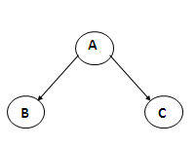
p(A,B,C) = p(B|A)p(C|A)p(A)
B and C are conditionally independent Given A
iv) 3-way Bayesian network (Markov dependence)

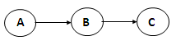
p(A,B,C) = p(C|B) p(B|A)p(A)

Problem 1
You have a new burglar alarm installed. It is reliable about detecting burglary, but responds to minor earth quakes. Two neighbors (John, Mary) promise to call you at work when they hear the alarm. John always calls when hears alarm, but confuses with phone ringing. Mary likes lod nusic and sometimes misses alarm. Find the probability of the event that the alarm has sounded but neither a burglary nor an earth quake has occurred and both Mary and John call.
Consider 5 binary variables
B=Burglary occurs at your house
E=Earth quake occurs at your home
A=Alarm goes off
J=John calls to report alarm
M=Mary calls to report the alarm
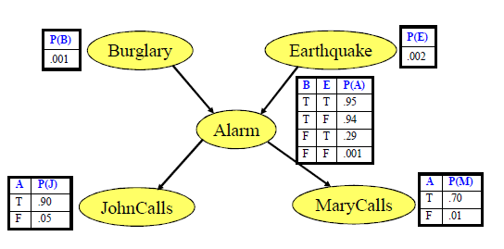
Probability of the event that the alarm has sounded but neither a burglary nor an earth quake has occurred and both Mary and John call
P(J,M,A,E,B)=P(J|A).P(M|A).P(A|E,B).P(E).P(B)
=0.90*0.70*0.001*0.99*0.998
=0.00062
Problem 2
Rain influences sprinkler usage. Rain and sprinkler influences whether grass is wet or not. What is the probability that rain gives grass wet?
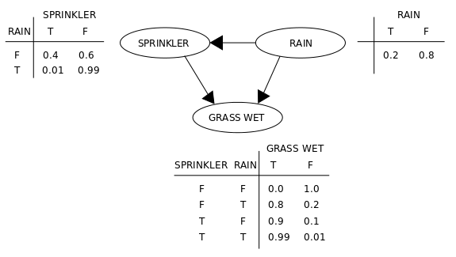
Solution
Let S= Sprinkler
R=Rain
G=Grass wet
P(G,S,R)=P(G|S,R).P(S|R).P(R)
=0.99*0.01*0.2
=0.00198
Problem 3
Bayesian Classifier: Training Dataset
Class:
C1:buys_computer = ‘yes’
C2:buys_computer = ‘no’
Data sample
X = (age <=30, Income = medium, Student = yes Credit_rating = Fair)
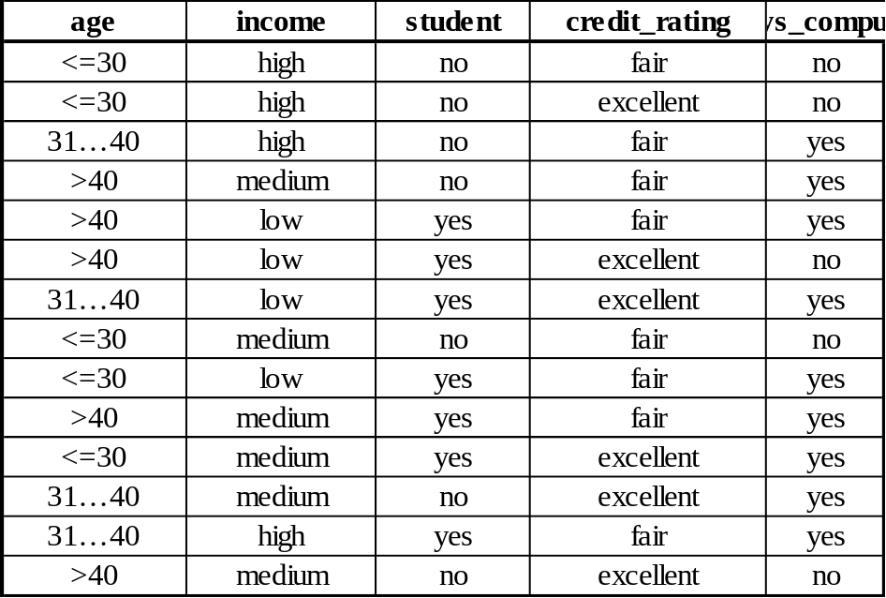

Solution
- P(Ci):
P(buys_computer = “yes”) = 9/14 = 0.643
P(buys_computer = “no”) = 5/14= 0.357
- Compute P(X|Ci) for each class
P(age = “<=30” | buys_computer = “yes”) = 2/9 = 0.222
P(age = “<= 30” | buys_computer = “no”) = 3/5 = 0.6
P(income = “medium” | buys_computer = “yes”) = 4/9 = 0.444
P(income = “medium” | buys_computer = “no”) = 2/5 = 0.4
P(student = “yes” | buys_computer = “yes) = 6/9 = 0.667
P(student = “yes” | buys_computer = “no”) = 1/5 = 0.2
P(credit_rating = “fair” | buys_computer = “yes”) = 6/9 = 0.667
P(credit_rating = “fair” | buys_computer = “no”) = 2/5 = 0.4
- X = (age <= 30 , income = medium, student = yes, credit_rating = fair)

P(X|C_{i}) :
P(X|buys_computer = “yes”) = 0.222 x 0.444 x 0.667 x 0.667 = 0.044
P(X|buys_computer = “no”) = 0.6 x 0.4 x 0.2 x 0.4 = 0.019
P(X|C_{i})*P(C_{i}) :
P(X|buys_computer = “yes”) * P(buys_computer = “yes”) = 0.028
P(X|buys_computer = “no”) * P(buys_computer = “no”) = 0.007
Therefore, X belongs to class (“buys_computer = yes”)

Problem 4
Did the patient have malignant tumour or not?
A patient takes a lab test and the result comes back positive. The test returns a correct positive result in only 98% of the cases in which a malignant tumour actually present, and a correct negative result in only 97% of the cases in which it is not present. Furthermore, o.oo8 of the entire population have this tumour.
Solution:
P(tumour)=0.008 P(¬tumour)=0.992
P(+|tumour)=0.98 P(-|tumour)=0.02
P(+|¬tumour)=0.03 P(-|¬tumour)=0.97

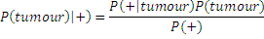
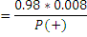
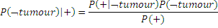
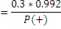
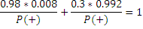
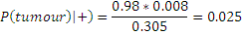
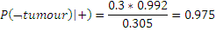
The probability of not having tumour is high. So the person is not having malignant tumour.

DEMPSTER - SHAFER THEORY
- This means that it is possible to believe that something could be both true and false to some degree
Dempster-Shafer theory is an approach to combining evidence. Dempster (1967) developed means for combining degrees of belief derived from independent items of evidence.
Each fact has a degree of support, between 0 and 1:
– 0 No support for the fact
– 1 full support for the fact
• Differs from Bayesian approach in that:
– Belief in a fact and its negation need not sum to 1.
– Both values can be 0 (meaning no evidence for or against the fact)

Set of possible conclusions:
ʘ = {ɵ₁, ɵ₂,…, ɵ_{n}}
– ʘ is the set of possible conclusions to be drawn
– Each ɵ_{i} is mutually exclusive: at most one has to be true.
– ʘ is Exhaustive: At least one ɵ_{i} has to be true.
Mass function m(A):
(where A is a member of the power set)= proportion of all evidence that supports this element of the power set.
Each m(A) is between 0 and 1.
• All m(A) sum to 1.
• m(Ø) is 0 - at least one must be true.
Belief in A:
The belief in an element A of the Power set is the sum of the masses of elements which are subsets of A (including A itself).
A={q1, q2, q3}
Bel(A) = m(q1)+m(q2)+m(q3) + m({q1, q2})+m({q2, q3})+m({q1, q3})+m({q1, q2, q3})
Plausibility of A: pl(A)
The plausibility of an element A, pl(A), is the sum of all the masses of the sets that intersect with the set A:
pl({B,J}) = m(B)+m(J)+m(B,J)+m(B,S)+m(J,S)+m(B,J,S)

Problem 1
• 4 people (B, J, S and K) are locked in a room when the lights go out.
• When the lights come on, K is dead, stabbed with a knife.
• Not suicide (stabbed in the back)
• No-one entered the room.
• Assume only one killer.
• ʘ= { B, J, S}
• P(ʘ) = (Ø, {B}, {J}, {S}, {B,J}, {B,S}, {J,S}, {B,J,S} )
Mass function m(A):
• Detectives, after reviewing the crime-scene, assign mass probabilities to various elements of the power set:
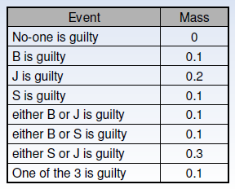

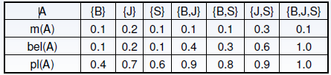
The certainty associated with a given subset A is defined by the belief interval: [ bel(A) pl(A) ].
From this we observed that J is a killer.

FUZZY REASONING
Fuzzy Logic (FL) is a method of reasoning that resembles human reasoning. The approach of FL imitates the way of decision making in humans that involves all intermediate possibilities between digital values YES and NO. In fuzzy logic, the degree of truth is between 0 and 1.
Example: William is smart (0.8 truth)
The fuzzy logic works on the levels of possibilities of input to achieve the definite output.
Fuzzy logic is useful for commercial and practical purposes.
- It can control machines and consumer products.
- It may not give accurate reasoning, but acceptable reasoning.
- Fuzzy logic helps to deal with the uncertainty in engineering.

Fuzzy Logic Systems Architecture
It has four main parts as shown −
- Fuzzification Module − It transforms the system inputs, which are crisp numbers, into fuzzy sets. It splits the input signal into five steps such as −
LP | x is Large Positive
MP | x is Medium Positive
S | x is Small
MN | x is Medium Negative
LN | x is Large Negative
- Knowledge Base − It stores IF-THEN rules provided by experts.
- Inference Engine − It simulates the human reasoning process by making fuzzy inference on the inputs and IF-THEN rules.
- Defuzzification Module − It transforms the fuzzy set obtained by the inference engine into a crisp value.
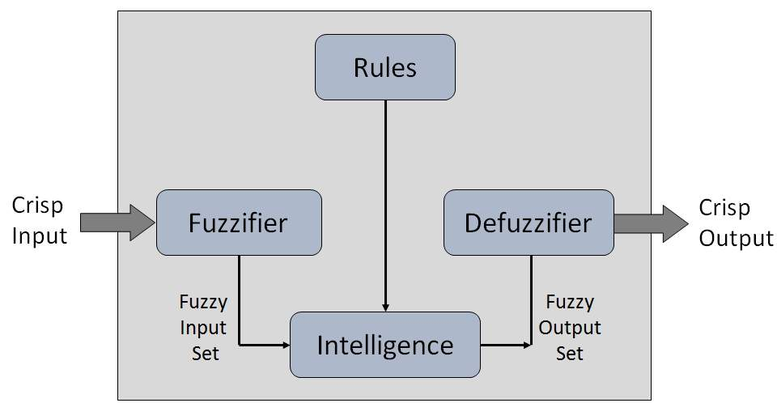
A membership function for a fuzzy set A on the universe of discourse X is defined as µA:X→[0,1].Here, each element of X is mapped to a value between 0 and 1. It is called membership value or degree of membership.
All membership functions for LP, MP, S, MN, and LN are shown as below −
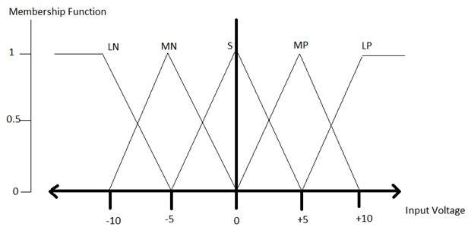
Here, the input to 5-level fuzzifier varies from -10 volts to +10 volts. Hence the corresponding output also changes.

Example of a Fuzzy Logic System
Let us consider an air conditioning system with 5-lvel fuzzy logic system. This system adjusts the temperature of air conditioner by comparing the room temperature and the target temperature value.

Algorithm
- Define linguistic variables and terms.
- Construct membership functions for them.
- Construct knowledge base of rules.
- Convert crisp data into fuzzy data sets using membership functions. (fuzzification)
- Evaluate rules in the rule base. (interface engine)
- Combine results from each rule. (interface engine)
- Convert output data into non-fuzzy values. (defuzzification)

Logic Development
Step 1: Define linguistic variables and terms
Linguistic variables are input and output variables in the form of simple words or sentences. For room temperature, cold, warm, hot, etc., are linguistic terms.
Temperature (t) = {very-cold, cold, warm, very-warm, hot}
Step 2: Construct membership functions for them
The membership functions of temperature variable are as shown −
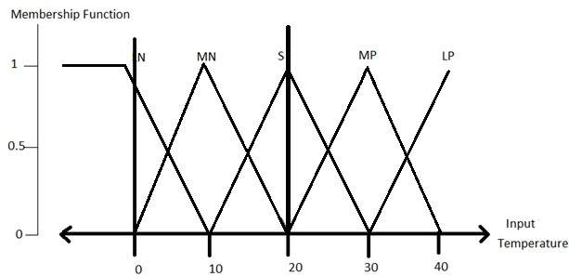
Step3: Construct knowledge base rules
Create a matrix of room temperature values versus target temperature values that an air conditioning system is expected to provide.
RoomTemp. /Target | Very_Cold | Cold | Warm | Hot | Very_Hot
Very_Cold | No_Change | Heat | Heat | Heat | Heat
Cold | Cool | No_Change | Heat | Heat | Heat
Warm | Cool | Cool | No_Change | Heat | Heat
Hot | Cool | Cool | Cool | No_Change | Heat
Very_Hot | Cool | Cool | Cool | Cool | No_Change
Build a set of rules into the knowledge base in the form of IF-THEN-ELSE structures.
Sr. No. | Condition | Action
1 | IF temperature=(Cold OR Very_Cold) AND target=Warm THEN | Heat
2 | IF temperature=(Hot OR Very_Hot) AND target=Warm THEN | Cool
3 | IF (temperature=Warm) AND (target=Warm) THEN | No_Change

Step 4: Obtain fuzzy value
Fuzzy set operations perform evaluation of rules. The operations used for OR and AND are Max and Min respectively. Combine all results of evaluation to form a final result. This result is a fuzzy value.
Step 5: Perform defuzzification
Defuzzification is then performed according to membership function for output variable.
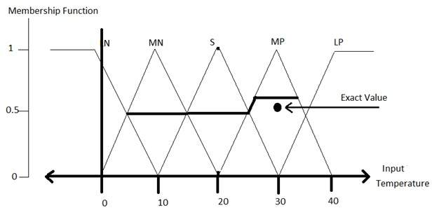

Application Areas of Fuzzy Logic
Automotive Systems
- Automatic Gearboxes
- Four-Wheel Steering
- Vehicle environment control
Consumer Electronic Goods
- Hi-Fi Systems
- Photocopiers
- Still and Video Cameras
- Television
Domestic Goods
- Microwave Ovens
- Refrigerators
- Toasters
- Vacuum Cleaners
- Washing Machines
Environment Control
- Air Conditioners/Dryers/Heaters
- Humidifiers

Advantages of Fuzzy Logic System
- Mathematical concepts within fuzzy reasoning are very simple.
- Able to modify Fuzzy Logic System by just adding or deleting rules due to flexibility of fuzzy logic.
- Fuzzy logic Systems can take imprecise, distorted, noisy input information.
- FLSs are easy to construct and understand.
- Fuzzy logic is a solution to complex problems in all fields of life, including medicine, as it resembles human reasoning and decision making.

Disadvantages of Fuzzy Logic System
- There is no systematic approach to fuzzy system designing.
- They are understandable only when simple.
- They are suitable for the problems which do not need high accuracy.

